**GRIET SKILL DEVELOPMENT CELL (SB)**

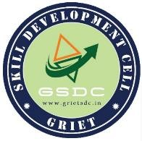

29th August 2022

Hyderabad

To

Head of Department, ECE GRIET, HYDERABAD.

**Sub: Request to allot Room no 2502 to conduct recruitment interviews for SDC-SB .**

Respected Ma’am,

We, team SDC-SB GRIET, want to conduct recruitment interviews for the 1st and 3rd years. We kindly request you to grant us access **to Room no 2502 in** **BLOCK 2 on Tuesday 30th August** **from 9:30 AM to 4:30 PM** as we need to recruit them into SDC-SB. Kindly oblige our request.

Thanking you

Yours Faithfully

J. Charan Teja Reddy

(President SDC SB)

__________________ __________________

Dr. G. S. Bapi Raju Dr. V. Himabindu

(Chief Instructor SDC) (HOD ECE)